**NNS Lab 4 - Answer Sheet**

Routing

Student Name: Steven

Student Surname: Raaijmakers

Student Number: 10804242

Operating System: Ubuntu 16.04

Task 1.

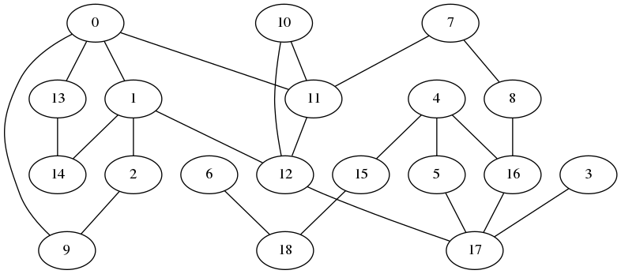Transformed graph plots.

Task 2.

1)

Write down the number of nodes in the shortest path

2)

Write down the name of nodes in the shortest path

3)

Identify the shortest path in the plots

Task 3.

2)

Shortest path between Adelaide1 and Brisbane1:

[0, 1, 12, 17, 16, 4]

['Adelaide1', u'Adelaide2', u'Melbourne2', u'Sydney2', u'Sydney1', u'Brisbane1']

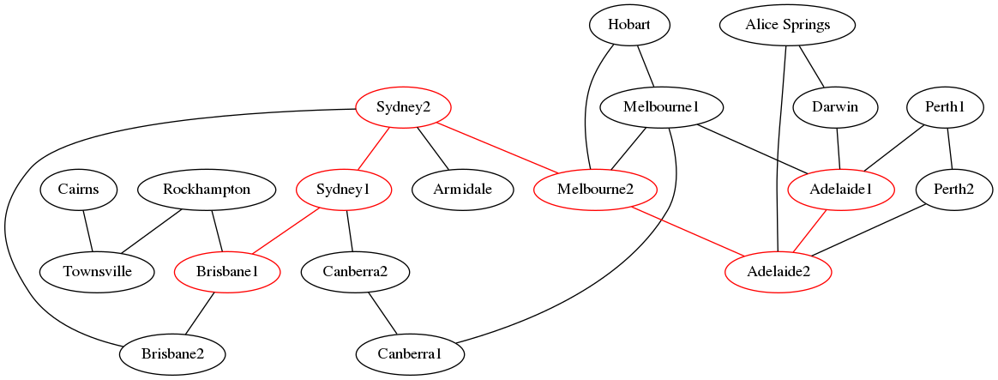

Write down all the shortest paths equal to the diameter of the network:

[u'Darwin', u'Adelaide1', u'Adelaide2', u'Melbourne2', u'Sydney2', u'Sydney1', u'Brisbane1', u'Rockhampton', u'Townsville', u'Cairns']

3)

Diameter = 6104.68192596 km

Write down the number.

There are 64 paths that exceed the cost of the shortest path between 1 and 6.

Task 4.

1) Yes, a tiny bit. The diameter changes to 6104.69251408

2) -